Lab 01 Combinational Circuits

Luis Echegaray

7/13/2014

Second Summer 2014

Purpose:

Our purpose was to familiarize ourselves with the eProduct Designer program. Most importantly, how to format the command file so we can do the simulations, and go through the difference between the builtin components and the Motorola (real) components. The rest of the tutorial guides us through finishing our NOT, AND, OR, and XOR gates, then adding it to our library. Using these components and what we learned in the tutorial, we implemented a 1-bit Ripple Adder, 1-bit Fuller adder, and finally a 4-bit Adder/Subtractor.

Analysis:

4bit adder / Sub-tractor Symbol

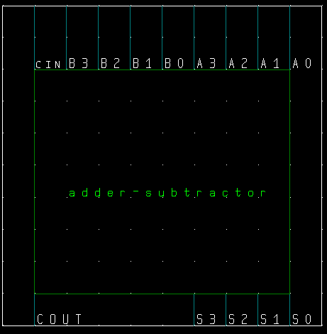

4bit adder / Sub-tractor Schematic

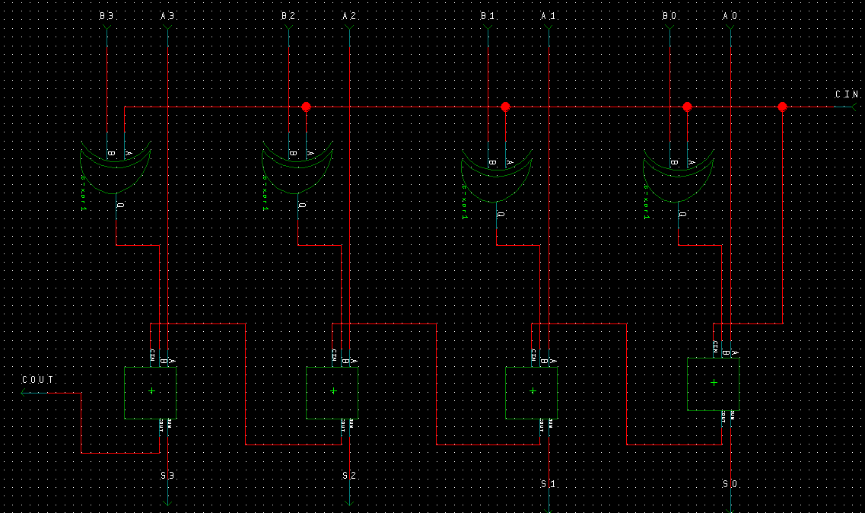

Adder-Subtractor Command File

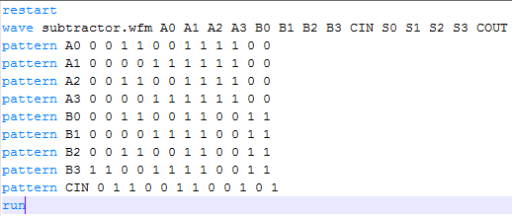

Expected Results

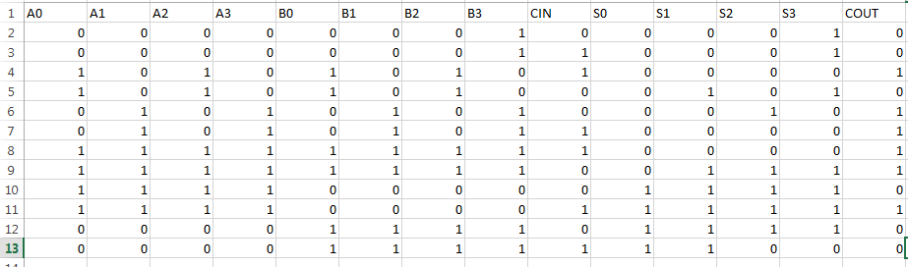

Simulation Screenshot with builtin components

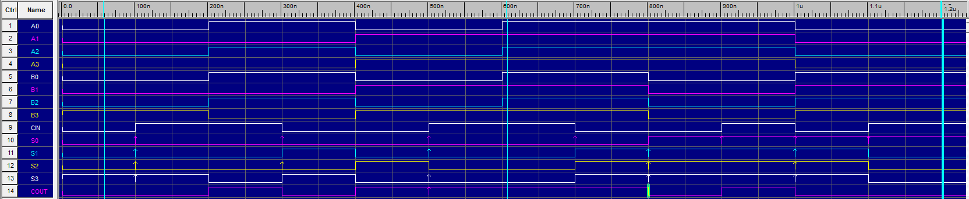

Simulation Screenshot with Motorola(real) components

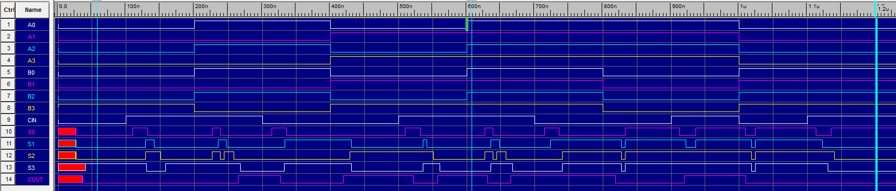

1 bit adder (half adder) Symbol

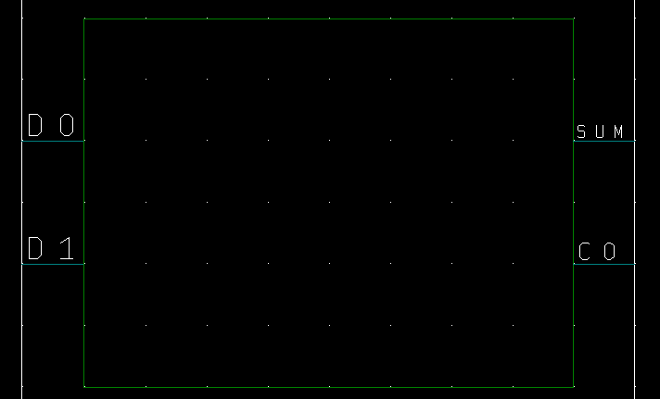

1 bit adder (half adder) Schematic

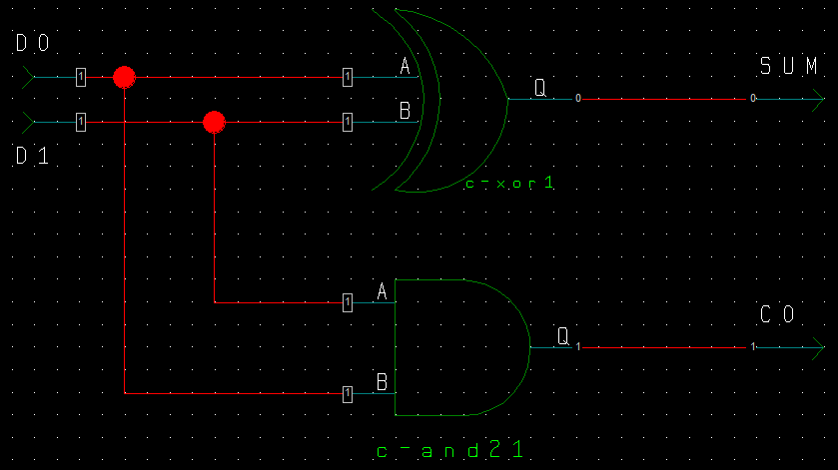

1 bit adder (half adder) Command File

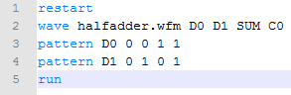

Expected Results

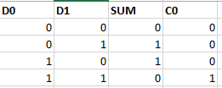

Simulation screenshot with **Motorola (real)** components



Xor gate Symbol

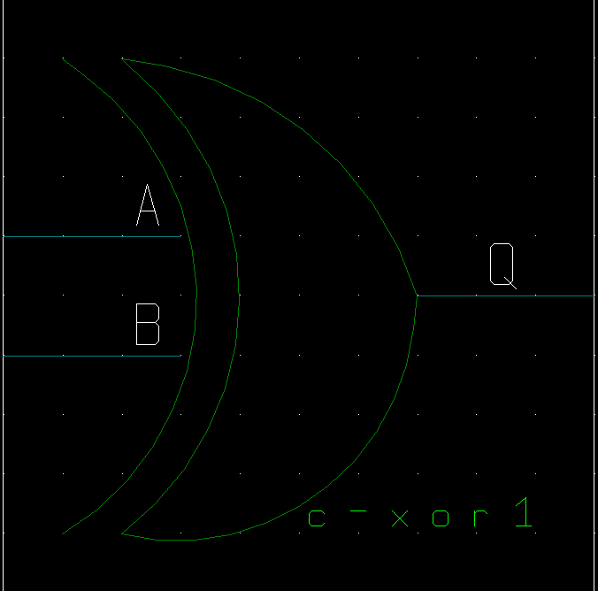

Xor gate Schematic

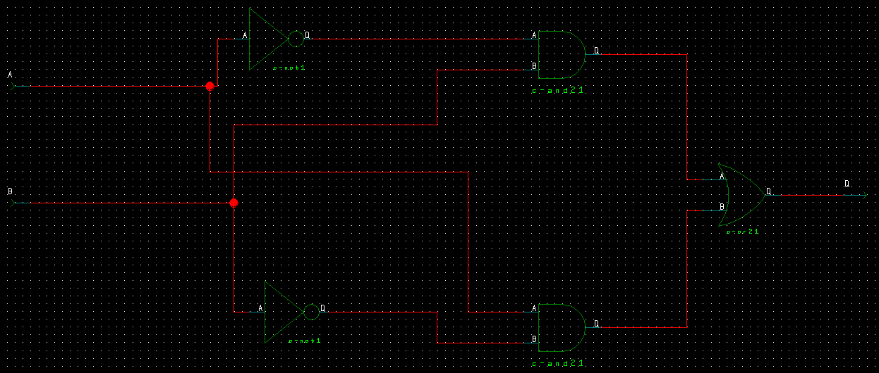

Xor gate Command File

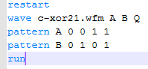

Xor gate Expected Results

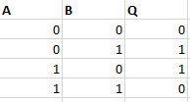

Simulation screenshot with **Motorola (real)** components

